PROJECT REPORT

**1.INTRODUCTION**

**Zoho Books is your one-stop platform for managing your accounting tasks and organizing your transactions. Zoho CRM gives your sales reps insight into every stage of your sales cycle—lead generation, lead capturing, conversion, retention, and loyalty.**

**1.1 OVERVIEW**

**Accounting's main feature is also classifying all business transactions. Accounting makes a group of all similar accounting entries in one place so, all transactions are collected under one common head. This system is also called classification of transaction.**.

**1.2PURPOSE:**

**Zoho Books is online accounting software that manages your finances, keeps you GST Compliant, automates business workflows, and helps you work collectively across departments.**

**2.Problem Definition& Design Thinking**

**2.1 EMPATHY MAP**

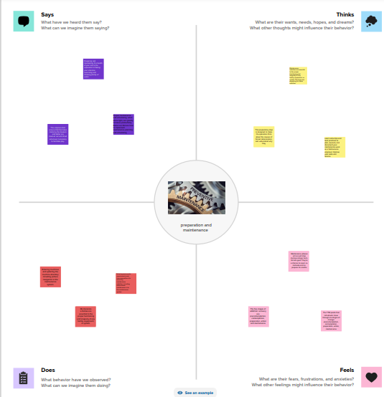

**2.2 IDEATION & BRAIN STORMING MAP**

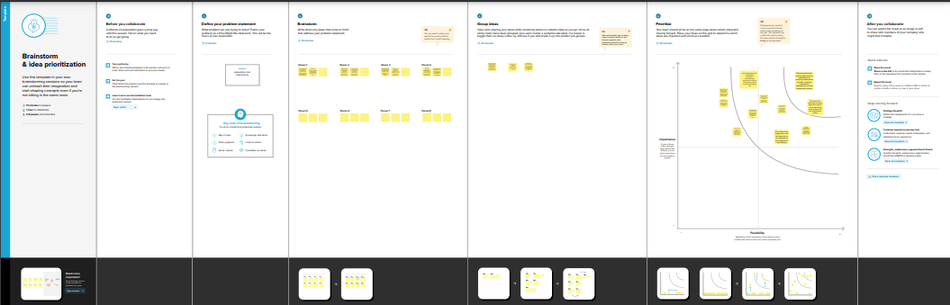

**3.RESULT**

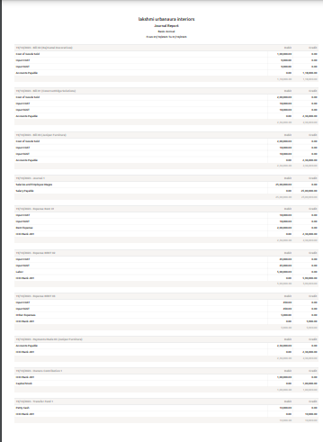

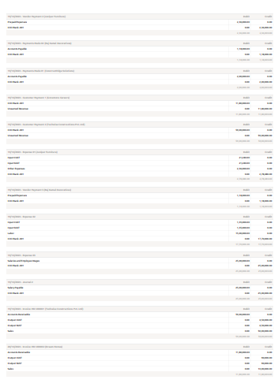

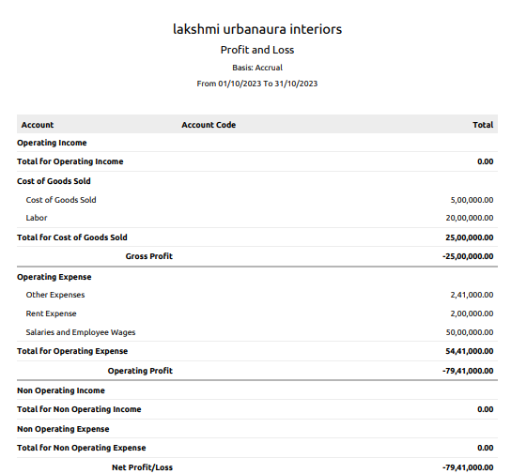

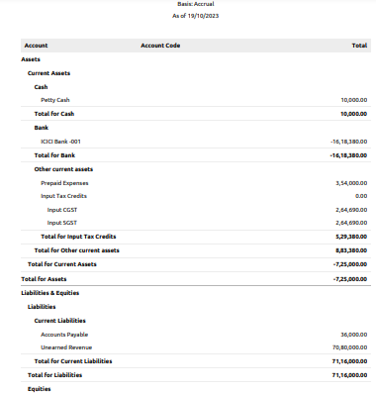

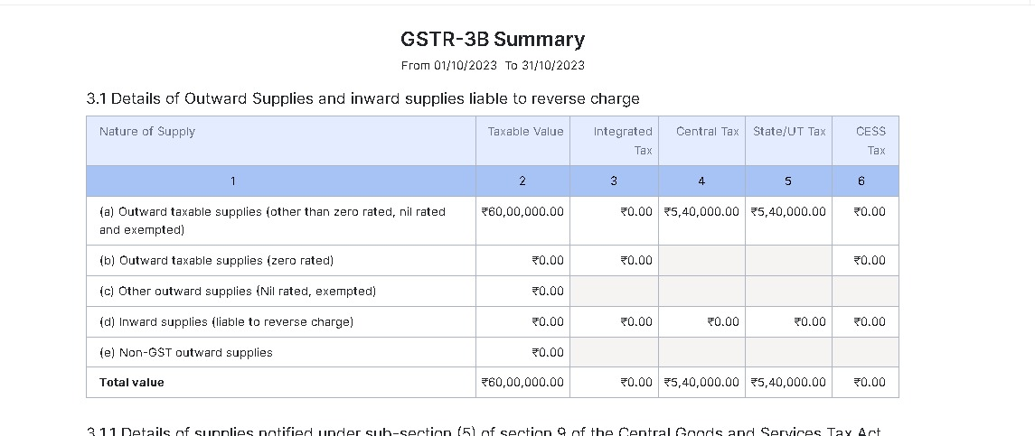

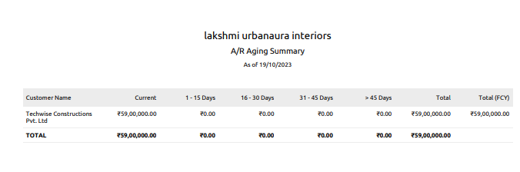

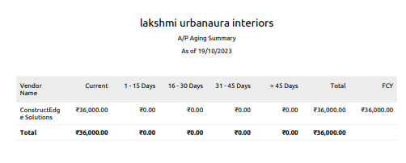

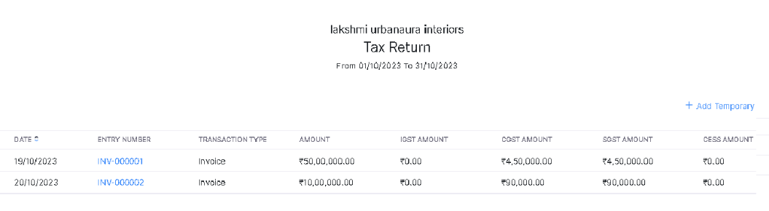

**VIDEO REPORT** <https://youtu.be/rJTzFvHAk0M?si=lcWBM_9XG7hx-any> **4.ADVANTAGES & DISADVANTAGES**

**While Zoho Books has excellent accounting features and automation abilities, we found a few drawbacks.**

* **Transaction cap. ...**
* **Monthly Multiple subscriptions for multiple businesses. ...**
* **Additional users require a fee. ...**
* **Fewer integrations than competitors. ...**
* **No payroll services. ...**
* **Accounts payable limitations.**

**5.APPLICATIONS**

* **Contact Management. Online Payments. Inventory Management. Expenses. Mobile Apps.**
* **Collaborative Customer Portal. Sales Order. GST compliant accounting. Project Time Tracking. Invoices.**
* **Invoice Templates. Automatic Bank Feeds. Purchase Order. Exhaustive Reports. Accounting.**

**6.CONCLUSION**

**Zoho Books is a powerful and versatile online accounting software that can help businesses of all sizes manage their finances and streamline their accounting processes**.

**7.FUTURE SCOPE**

**Zoho development is going to focus on cloud services. Furthermore, expectations are that cloud would form 70% of Zoho's business and 30% would be from on-premise offerings. However, Zoho is going to continue its global expansion plans**